UNITED STATES

SECURITIES AND EXCHANGE COMMISSION
Washington, D.C. 20549

SCHEDULE 14A

Proxy Statement Pursuant to Section 14(a) of the
Securities Exchange Act of 1934

(Amendment No.)

Filed by the Registrant ☒

Filed by a Party other than the Registrant ☐

Check the appropriate box:

- Preliminary Proxy Statement

- Confidential, for Use of the Commission Only (as permitted by Rule 14a-6(e)(2))

- Definitive Proxy Statement

- Definitive Additional Materials

- Soliciting Material under §240.14a-12

DNOW Inc.

(Name of Registrant as Specified In Its Charter)
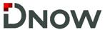

(Name of Person(s) Filing Proxy Statement, if other than the Registrant)

Payment of Filing Fee (Check all boxes that apply):

- No fee required

- Fee paid previously with preliminary materials

- Fee computed on table in exhibit required by Item 25(b) per Exchange Act Rules 14a-6(i)(1) and 0-11

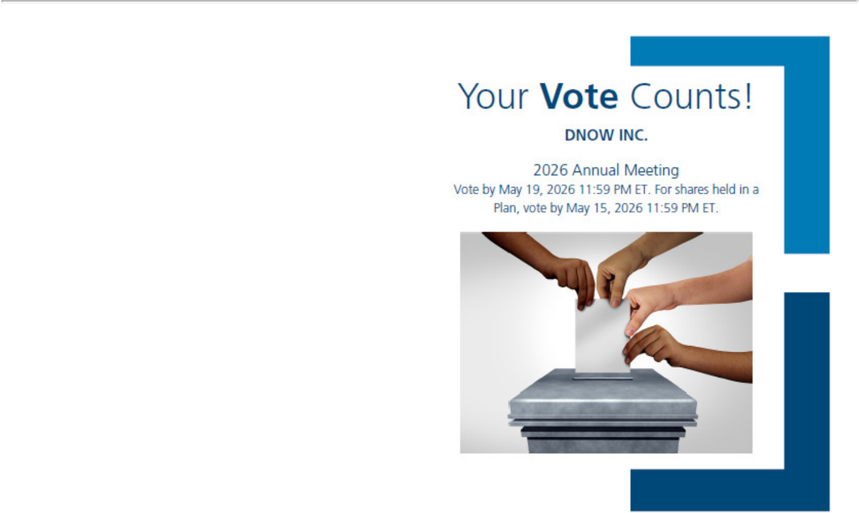

DNOW INC.
7402 NORTH ELDRIDGE PARKWAY
HOUSTON, TX 77041

V92710-P48376

You invested in DNOW INC. and it’s time to vote!

You have the right to vote on proposals being presented at the Annual Meeting. This is an important notice regarding the availability of proxy materials for the stockholder meeting to be held on May 20, 2026.

Get informed before you vote

View the Proxy Statement and the 2025 Annual Report on Form 10-K online OR you can receive a free paper or email copy of the material(s) by requesting prior to May 6, 2026. If you would like to request a copy of the material(s) for this and/or future stockholder meetings, you may (1) visit www.ProxyVote.com, (2) call 1-800-579-1639 or (3) send an email to sendmaterial@proxyvote.com. If sending an email, please include your control number (indicated below) in the subject line. Unless requested, you will not otherwise receive a paper or email copy.


Smartphone users |  | Vote in Person at the Meeting*
Point your camera here and |  | May 20, 2026
vote without entering a |  | 10:00 am Central Time
control number
 |  | 7402 N. Eldridge Parkway
 |  | Houston, Texas 77041



*Please check the meeting materials for any special requirements for meeting attendance. At the meeting, you will need to request a ballot to vote these shares.

Vote at www.ProxyVote.com

THIS IS NOT A VOTABLE BALLOT

This is an overview of the proposals being presented at the upcoming stockholder meeting. Please follow the instructions on the reverse side to vote these important matters.

Voting Items

Board

Recommends

1. | To elect nine directors to hold office for one-year terms;
 | Nominees:
1a. | Richard Alario | For
1b. | Terry Bonno | For
1c. | David Cherechinsky | For
1d. | Galen Cobb | For
1e. | Paul Coppinger | For
1f. | George Damiris | For
1g. | Karen David-Green | For
1h. | Ronald Jadin | For
1i. | Sonya Reed | For
2. | To consider and act upon a proposal to ratify the appointment of KPMG LLP as independent auditors of the | For
 | Company for 2026; | For
3. | To consider and act upon an advisory proposal to approve the compensation of our named executive officers. | For
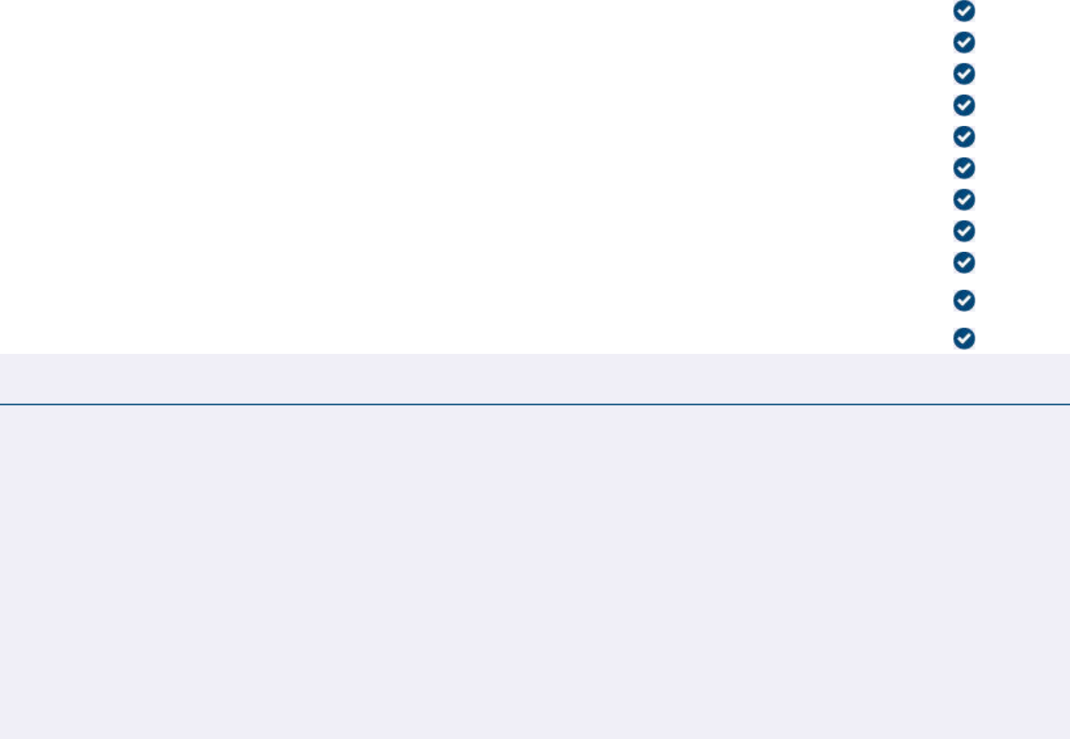

NOTE: To consider and act upon any other matters that may properly come before the annual meeting or any postponement or adjournment thereof.

Prefer to receive an email instead? While voting on www.ProxyVote.com, be sure to click “Delivery Settings”.

V92711-P48376

